Have You Been Victimized by Your PPO Contract - You May Not Be Aware!
UNCOVER THE SECRET – PPO Plans Do Not Want You to Know!
It is preventing your practice from collecting 24% - 43% more in your claim reimbursements.
I recently received an email from an attorney friend of mine containing a Letter of Advisement issued from Wisconsin Dental Association to its members. The letter stated some dental benefit companies have recently amended their provider agreements to include provisions not previously incorporated into the original contract. My friend contacted me to forewarn me that the State of Michigan may be next. I quickly responded, “Wisconsin is not the only state, Michigan and several other states have already been impacted.”
Some of the amendments cover a variety of subjects, such as the following:
◾Benefit companies are now including language that indicates they may engage in a rented network in the future; even though, they do not presently engage.
◾A requirement to report all other contracts paying a lesser fee schedule than this specific company.
◾A suggestion that if one dentist of a multi- dentist practice participates with a dental benefit company, all the other dentists must also be participating with that same company.
◾A requirement that the dentist must notify patients if they choose to terminate its participation with a particular benefit company. They must also refer those patients to another provider who does contract with the said benefit company.
What does this mean for dentists that PARTICIPATE with such groups?
It means that they could be paid on a lesser fee schedule and writing off 24% - 43% more than they did before. This drastically cuts into a practice’s bottom line.
I have a great example for you to visualize how these provisions can dramatically affect any dental practice. A “fee for service” dental practice hired an associate about 3 years ago. In order to keep the associate busy, they decided to credential with only 2 PPO plans and remain out of network with the other groups. You may be able to relate to this. The sample fee schedule illustrated on Chart 1.1 shows how the associate would be writing off an average of 45% - 52% on services rendered under these two PPO plans. The only reason they accepted these lower fees was that they were told the associate would have access to a large pool of patients.
Chart 1.1 : Comparison Between Standard Fee and PPO Fee
If you could only imagine the shock on the doctor/owner’s face when she was informed their associate was considered in-network with 5 other dental groups, as a result of their contract with the original 2 groups. Simply stated, the associate is under a total of 7 dental benefit groups being paid on the reduced fee agreed upon with the original 2 groups they enlisted with. 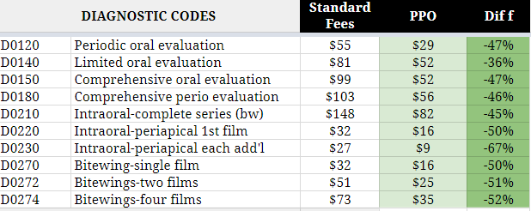
Are you currently a Victim? You already may be a Victim or a potential victim if you can answer yes to any of the questions posted below.
❐ Is Your practice currently in network with various PPO plans and writing off over 32% from
your standard fees?
❐ If you are a single provider, are the EOB’s being paid on a different fee schedule that you
anticipated?
❐ If you are practice with multiple providers, are the EOB’s being paid differently for each
associate from the same dental benefit company?
❐ Already in a variety of plans and not certain if your practice has been affected?
❐ Are you looking to purchase a practice signed up with a variety of dental benefit groups?
❐ Are you a dentist looking to join a group that is signed up with a variety of Dental benefit
groups?
What Should you do if you feel you are a Victim or potential Victim?
✔ Review the dental benefit group contract carefully and see if there are any provisions cited before you join.
✔ Identify the type of contract the providers are in- network; direct, rented or 3rd party
payor.
✔ Review every EOB and make sure it is being paid on the fee schedule you expected it to be
paid on.
✔ Check patient's eligibility prior to their visit and ask the insurance representative what fee
schedule the patients plan will be paid on.
✔ Do you feel you or your practice has become a victim of the Insurance game? Are you tired of
feeling you have no other choices?
Visit the following link and obtain a complimentary evaluation by a Strategic Practice Solutions Representative and walk away with at least 2 actionable items specific to your situation.
www. strategicpracticesolution.com/insurance

